Tic tac toe

# Project link:

<https://in-info-web4.informatics.iupui.edu/~kylperry/n320/game_tictactoe/>

For this project I’ve created a game of Tic Tac Toe.

For Classes, I have three:

1. Game class
   1. The game class
2. Board class
   1. Is used to track the state of the game board
   2. Include methods to update the game board visually and track the win conditions
   3. A means to wipe the board for new games.
   4. Checks win conditions after each player’s move
3. Player class
   1. Is used to generate the piece, X or O to track the moves a player makes
4. The Game class is used to manage the other classes and run the game
   1. It runs update to check if the game has ended, switch turns, and generate messages to the users.

For the CSS animation, I wanted to use a neat animation each time a game started to kind of wipe the board, but I couldn’t figure out how to get the trigger and animations to work, so instead I used the css animation to have the H1 title shift colors and give the page a less static and more whimsical feeling.

WireFrame:

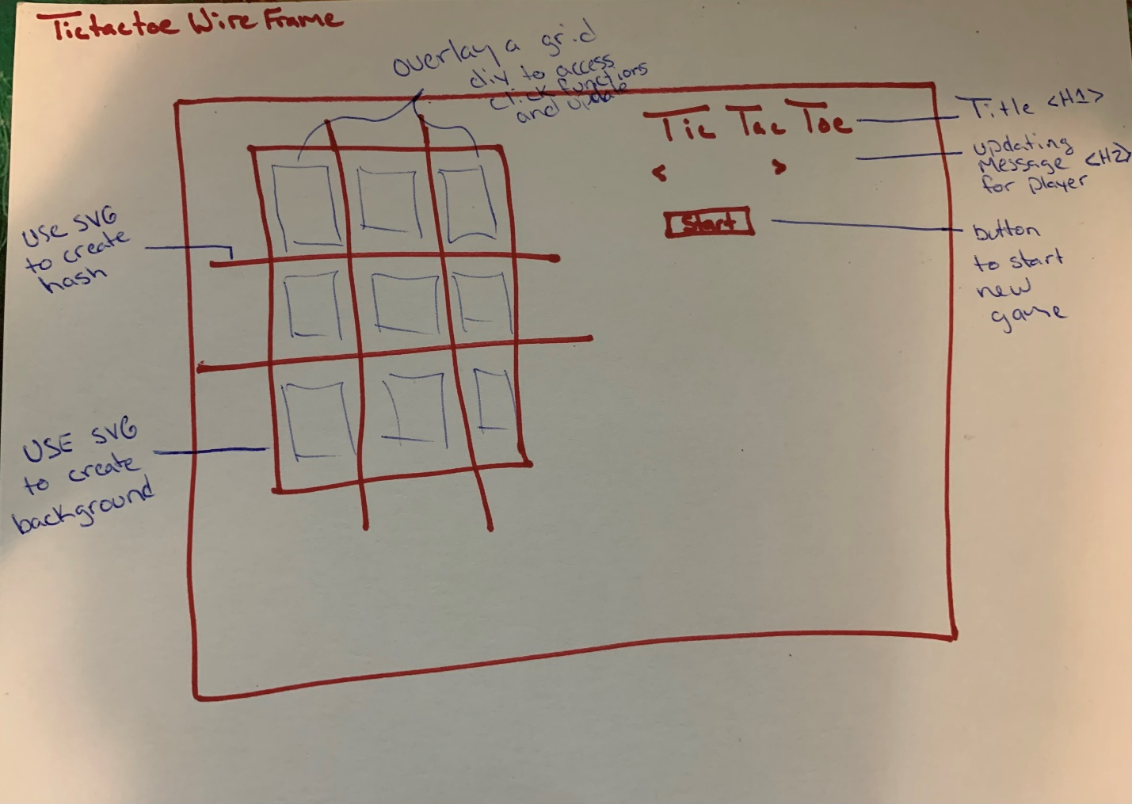

Classes and Class Relations:

Many (2)

1

1

1

Has

Player

Board

Has

Game